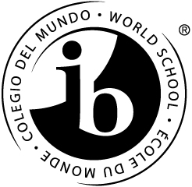
WE ARE IB: Sequoia is an IB School
We Welcome Your Student

Is Your Student Attending Sequoia High School Next Year?
Come learn about why your student should take IB courses and how your student can be successful in high school.
- IB is an honors “program” challenging students to their fullest academic potential
- IB emphasizes global mindedness, respecting all perspectives
- IB values all students
- IB prepares students for college and the real world
- IB develops critical thinking, speaking and writing skills
- IB encourages students to care about others and give back to their community
- IB is for all ALL students. IB is for you!

You and your student are invited to the:
8th Grade IB Information Meeting
Wednesday, January 13, 2016
Sequoia High School
Carrington Hall
1201 Brewster Avenue
Redwood City
6:00 – 7:30 P.M.
(The English meeting is at 6pm and the Spanish meeting is at 7pm)
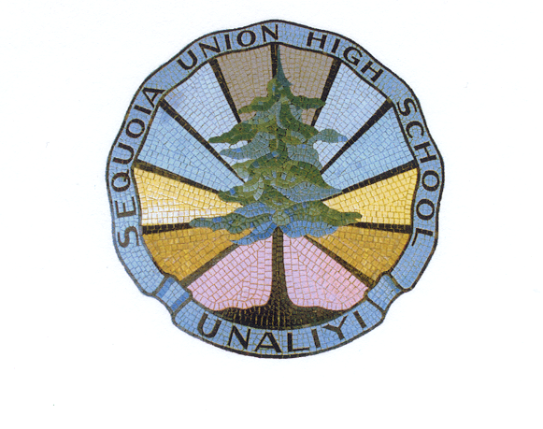
Facilitated by Lisa McCahon, IB Coordinator

